Clients and servers

Client and server roles

- **All computers connected to a network that participate directly in network communication are classified as hosts**

- Hosts can send and receive messages on the network

- In modern networks, computer hosts can act as a client, a server, or both the software installed determines which role it plays

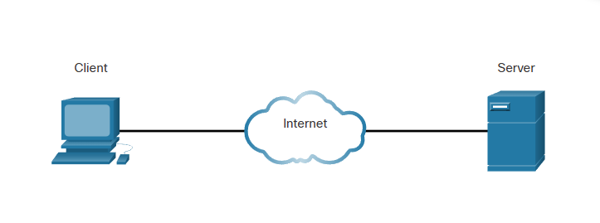

SERVERS

Are hosts that have software installed which enable them to provide information (email/web pages…)

Each service requires separate server software

CLIENTS

Computer hosts that have software installed that enable the host to request and display the information obtained from the server

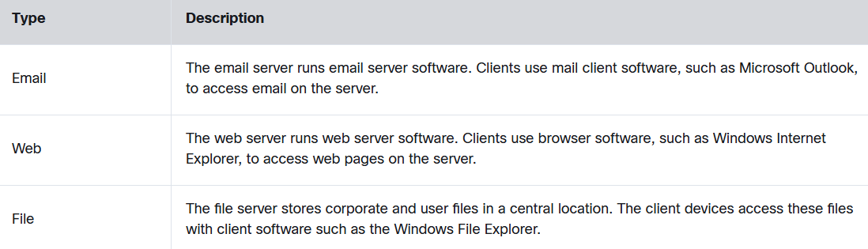

Peer-to-peer networks

**It is possible for one computer to run both client and server software at the same time** and this is called P2P or Peer-to-peer network

The simplest P2P network consists of 2 directly connected computers using wired/wireless connection (exchange data and services with each other, acting as vlient or server)

Multiple PCs can also be connected to create P2P but it requires a network device, like switch

MAIN DISADVANTAGE is that the performance of a host can be slowed down if it is acting as both a client and a server at the same time

ADVANTAGES DISADVANTAGES

**- easy to set up - no centralized administration**

**- less complex - not as secure**

**- lower cost (no need for server) - not scalable**

**- can be used for simple tasks - all devices can act as both and it can slow their performance**

Peer-to-peer applications

**They allow a device to act as both a client and a server within the same communication**

Hybrit system - resource sharing is decentralized, but the indexes that point to resource locations are stored in a centralized directory

Each peer accesses an index server to get the location of a resource stored on another peer

Multiple roles in the network

**A computer with server software can provide services simultaneously to one or many clients**

**Additionally, a single computer can run multiple types of server software**

Single computer can also run multiple types of client software

Client software for every service required with multiple clients installed, a host can connect to multiple servers at the same time

